*Hong Kong Exchanges and Clearing Limited and The Stock Exchange of Hong Kong Limited take no responsibility for the contents of this announcement, make no representation as to its accuracy or completeness and expressly disclaim any liability whatsoever for any loss howsoever arising from or in reliance upon the whole or any part of the contents of this announcement.*

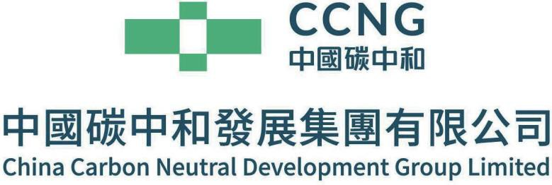

*(Incorporated in the Cayman Islands with limited liability)*

(Stock code: 1372)

Voluntary Announcement

Business Update

This announcement is a voluntary announcement made by China Carbon Neutral Development Group Limited (the "Company"), together with its subsidiaries (the "Group").

The Board of Directors of the Company is pleased to announce that on 19 August 2024, China Carbon Luxin Technology (Shenzhen) Co. Ltd., a wholly-owned subsidiary of the Company, received the notice of winning the bid for the government procurement project of the Jiyuan Industry-City Integration Demonstration Zone, providing the "Jiyuan Industry-City Integration Demonstration Zone Development, Reform and Statistic Bureau with Preparation Project relating to Jiyuan City Carbon Peak and Carbon Neutrality Development Implementation Plan" service for the Jiyuan Industry-City Integration Demonstration Zone ("Jiyuan"). Based on the content of the winning bid, the Group will sort out the domestic and foreign dual carbon policies, analyze the impact on Jiyuan, and propose coping strategies; and help Jiyuan formulate a local dual carbon strategy, put forward specific strategies to achieve dual carbon by analyzing Jiyuan's industrial structure, energy consumption and carbon emissions, clarify the technical path, and formulate emission reduction policies and measures for key areas of Jiyuan.

The Board takes the view that the acquisition of the implementation plan for carbon peak and carbon neutrality development in the Jiyuan Industry-City Integration Demonstration Zone is a major breakthrough in the Group's carbon consulting business, which strengthens the Group's strategic positioning of providing "one-stop" carbon neutrality solutions, and provides an effective entry point for the neutralization business, directly covering Jiyuan electric power, steel, nonferrous metals, chemical and other industries, including more than 1,900 industrial enterprises, which enables the Group's discussing consulting, carbon planning, and products on carbon peaking and carbon neutrality digital platforms to obtain huge application scenarios. It also enables the expansion of the field of carbon asset development and operation.

Since its establishment in 2017, the Jiyuan Industry-City Integration Demonstration Zone has been the country's first demonstration of industry-city integration, aiming to lead industrial upgrading and deep urban integration. Covering an area of 1,898.73 square kilometres, the district has a number of development zones, towns and sub-districts, building a solid development framework. Following the provincial and municipal planning, the demonstration zone takes green and low-carbon recycling as the core, adheres to ecology, innovation and coordinated development, optimizes the industrial structure, and promotes the formation of a high-quality modern industrial system. At the same time, it is committed to creating a new model of livability, business and tourism, improving the quality of the economy, the quality of the city and the happiness of residents, and achieving a win-win situation in production, life and ecology.

By order of the Board

**China Carbon Neutral Development Group Limited**

Zhong Guoxing

*Chairman and Executive Director*

Hong Kong, 5 September 2024

*As at the date of this announcement, the Executive Directors are Mr. Zhong Guoxing, Mr. Di Ling and Mr. Lu Xiangyong; and the Independent Non-executive Directors are Mr. Wang Anyuan, Mr. Wang Jiasi and Ms. Lan Haiqing.*